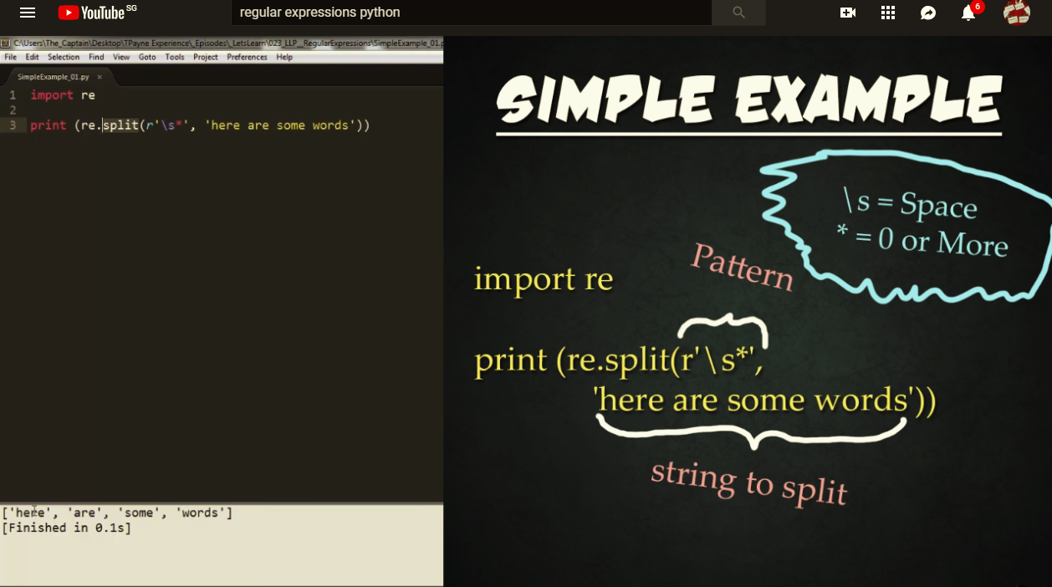

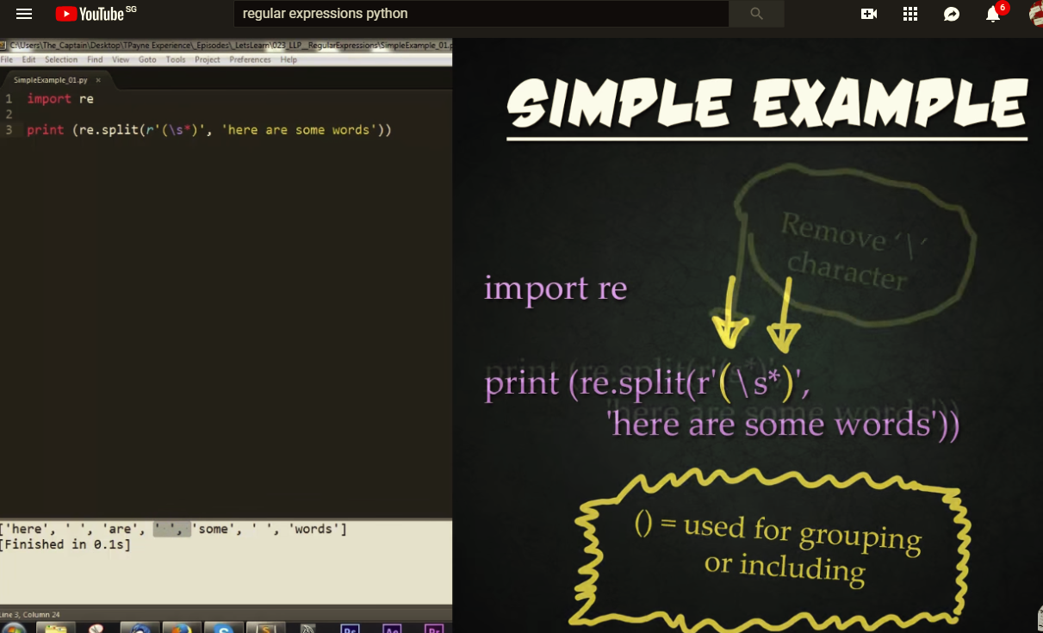

**Evaluate s as an ordinary character**

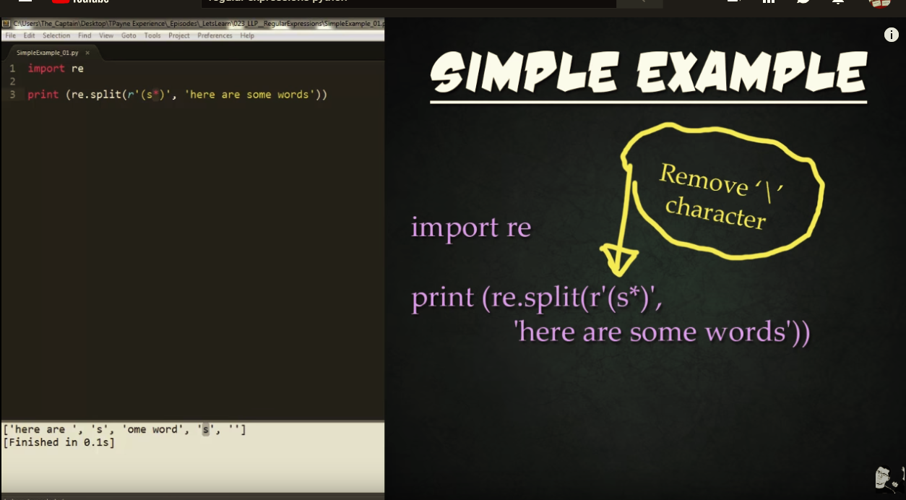

**Find a range of characters from a to z and split**

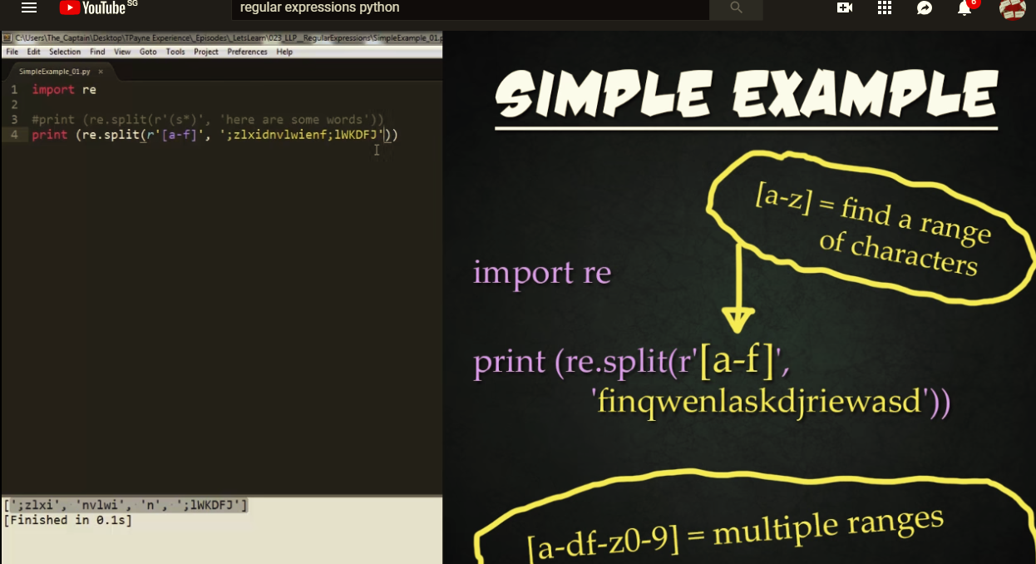

**Finding a range of characters adjacent to each other (in this example is a-f and a-f side by side) and split**

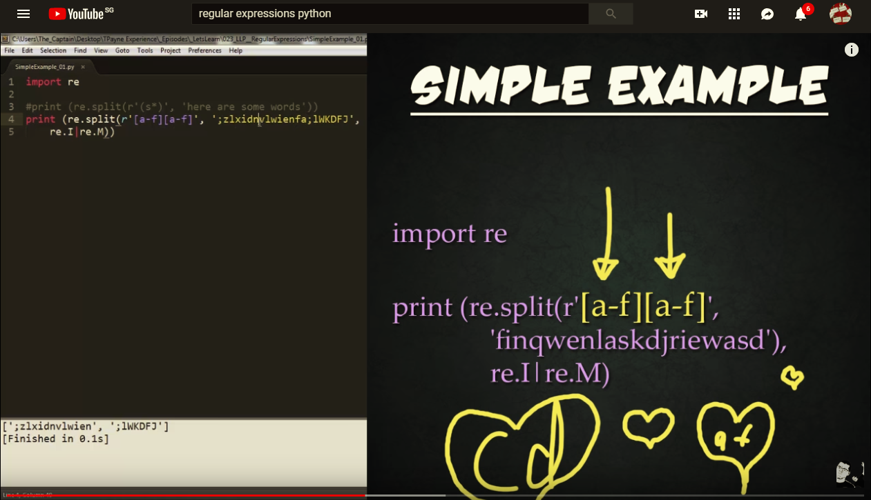

**Splitting based on address**

